**HW Assignments #2**

**-HTML and JavaScript-**

**19102127**

**ITM Suho Lee**

1. **Get two numbers using prompt, calculate the summation of two numbers and alert the result.**
2. Result is below.

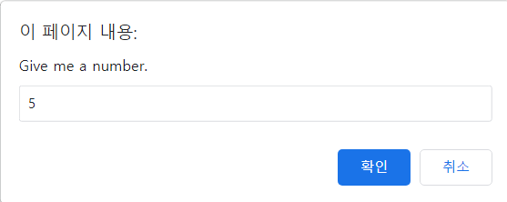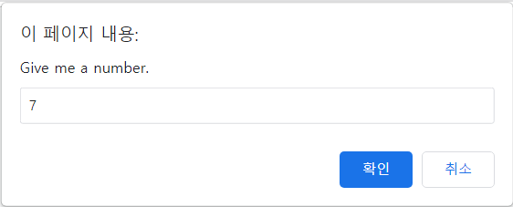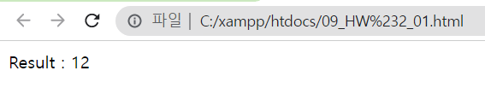

1. Codes and Explanations are below.

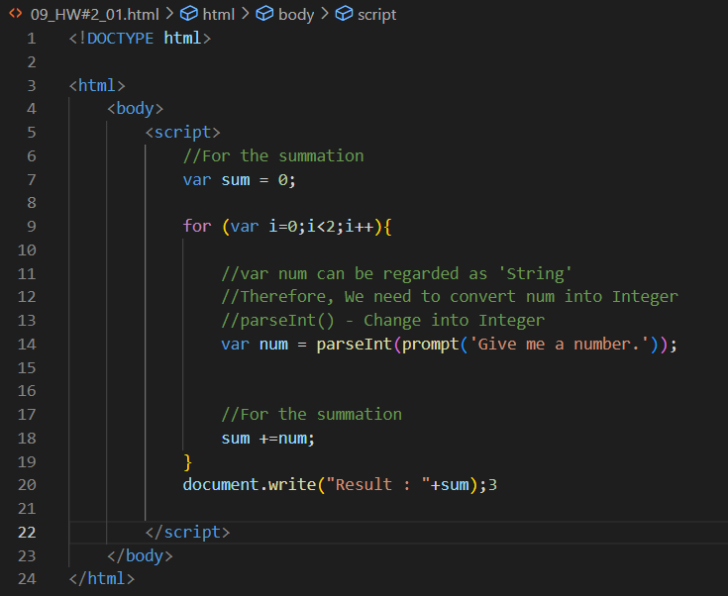

1. **Get two numbers using prompt while satisfying the following requirement.**
2. Result is below.

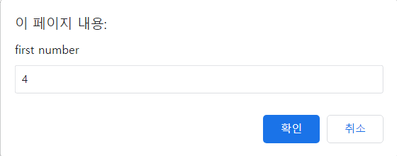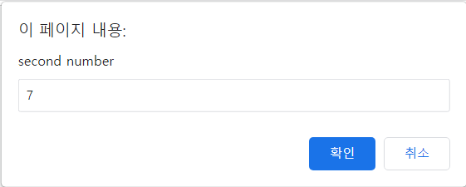

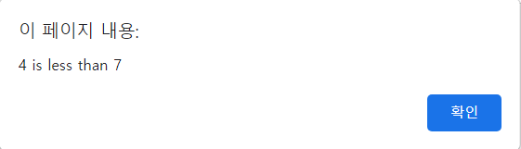

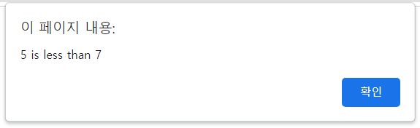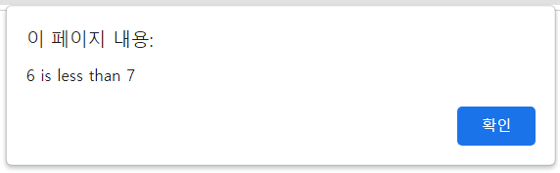

1. Codes and Explanations are below.

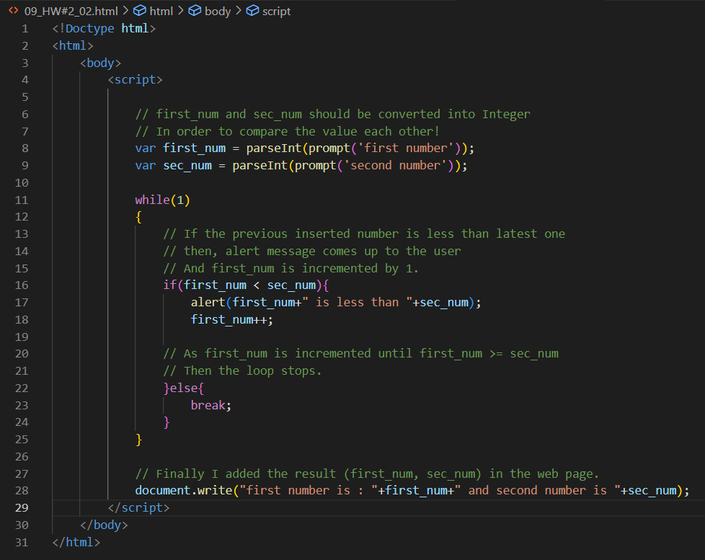

1. **Generate a random number and Compare the number and Alert the comparison result**
2. Results are below

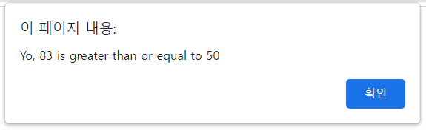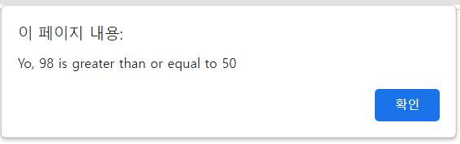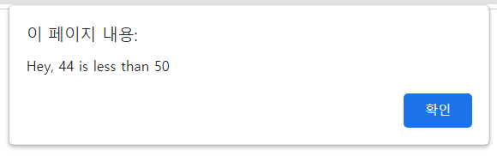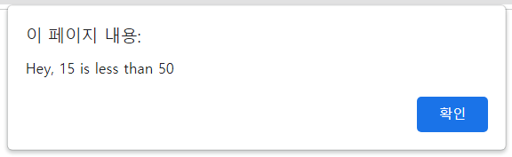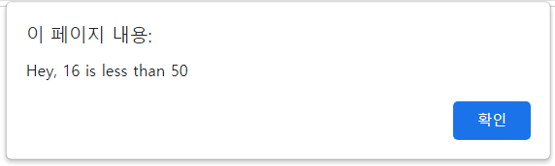

1. Codes and Explanations are below.

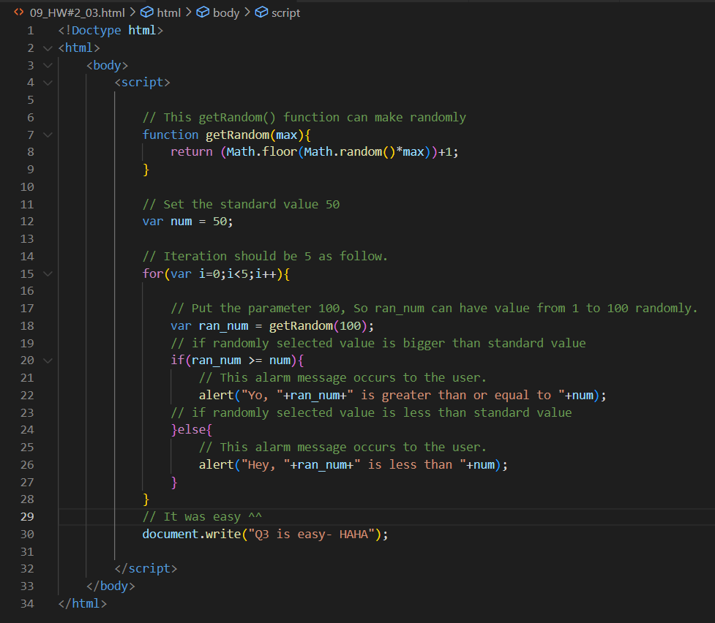

1. **Calculate the result (+, -, *, /) and show the result in each blank.**
2. Result is below.





1. Codes and Explanations are below.

